[Toomer Elementary]
Date: [January 21, 2020]
Time: [5:00 pm]
Location: [Toomer Library]

- Call to order: [4:36 pm]
- Roll Call
Role | Name (or Vacant) | Present or Absent
Principal | Caroline Brown | Present
Parent/Guardian | Catherine Harper | Present
Parent/Guardian | Celeste Walley-Jean | Present
Parent/Guardian | Bianca Betts | Absent
Instructional Staff | JaBria Cooper | Present
Instructional Staff | Kaitlin Clark | Present
Instructional Staff | Khadija Washington | Present
Community Member | Vijay Makar | Present
Community Member | Neill Davis | Present
Swing Seat | Joseph Wang | Present

Quorum Established: [Yes]
- Action Items (add items as needed)
  - Approval of Agenda: Motion made by: [Celeste Walley-Jean]; Seconded by: [Kaitie Clark]
Members Approving: unanimous
Members Opposing:
Members Abstaining:
Motion [Passes]
  - Approval of Previous Minutes: Motion made by: [Celeste Walley-Jean]; Seconded by: [Joseph Wang]
Members Approving: unanimous
Members Opposing:
Members Abstaining:
- Information Items
  - Principal’s report: summary of data
    - Look back on notice and wonderings from previous meeting
    - 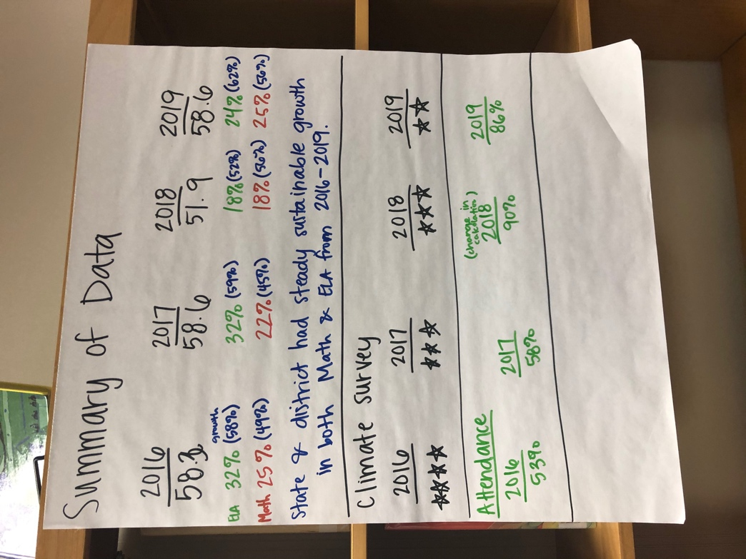
- Discussion Items
  - Ranking priorities and budget development
    - (2) Develop protocols & systems to support student needs (something needs to be done to address star rating)
    - (1) Focus on instructional practices
      - Closing achievement gap
      - Increase percentage of students at proficient or above
    - (3) Focus on math as we have focused on literacy
- Announcements
  - Moving February meeting date – NOT moving it. Meeting will still be 2/27
  - Attend budget training before February meeting date
  - March budget approval date: March 3rd (
- Public Comment
  - Afterschool program
- Adjournment
Motion made by: [Kaitie Clark]; Seconded by: [Joseph Wang]
Members Approving: Unanimous
Members Opposing:
Members Abstaining:
Motion [Passes]
ADJOURNED AT [6:15 PM]
-----------------------------------------------------------------------------------------------------------------------------
Minutes Taken By: [Kaitie Clark ]
Position: [Secretary]
Date Approved:

